- Call to Order: at 1:01 pm by Vice President Kelly Alter.

- Pledge of Allegiance: Kelly Alter led the Pledge of Allegiance.

- Proof of Notice and Quorum: The meeting was posted on June 23, 2025.

- In Attendance: Kelly Alter, Ed Raether, Anthony Dinallo, Michael Scieszka, Dann Stavro, and Christine Dixler. Absent: Cynthia Thompson

- In Attendance: Jody Clor – General Manager; Ron Kelly – General Services Manager; Marti Provenzano – Member Relations Director; Shawn McCormick – Assistant General Manager

- Approval of Board Meeting Minutes 4-28-25: Kelly Alter made a motion to approve the Board Meeting Minutes. Christine Dixler seconded the motion. Vote: 6-0 Motion Passes

- Approval of Board Meeting Minutes 5-28-25: Kelly Alter made a motion to approve the Board Meeting Minutes. Dann Stavro seconded the motion. Vote: 6-0 Motion Passes

- President’s Report: Vice President Kelly Alter gave the report on the following topics:
  - Town Hall Meeting
  - Replacement of Departing Board Member.

- Treasurer’s Report:

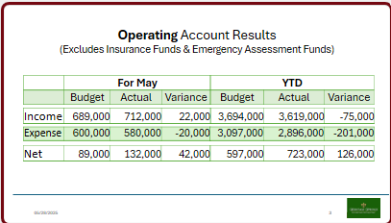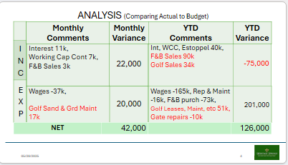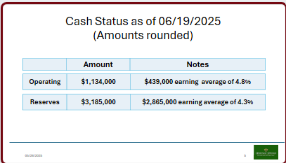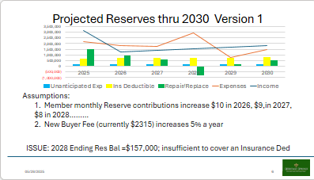
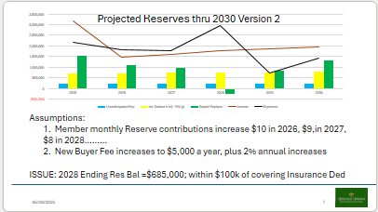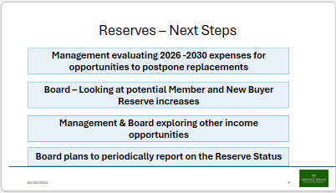

- General Manager’s Report: Jody Clor provided updates for the following topics: Finance, IT, HOA, Golf, General Services & Facilities, Food & Beverage and Human Resources.

- Committee Reports: Alan Dixler shared an update from the Finance Committee. Cheri Smith shared an update from the Lifestyle & House Committee. Dan Rooney shared an update from the Architectural Review and Control Committee. Mike Spicker shared an update from the Facilities Committee. Lynne Simmons shared an update from the Insurance Committee. Christine Dixler shared an update from the Rule and Policy Committee for the Chairperson, Bob Johnstone.

- Member Comments on Agenda Items: Several members made comments or suggestions.

- Motion to Approve Presenting Bylaw Edits to Members for Vote: Christine Dixler made a motion for the Heritage Springs Community Association Board of Directors to approve bringing the proposed amendment to the Bylaws before the Members for a vote as soon as practicable: To amend Article IV, Section 2, Board of Directors: Selection and Term of Office: To change the term of office for Directors of the Board from two (2) years to three (3) years. Motion seconded by Dann Stavro. Motion passes 6-0.

- Motion to Approve CAP – Swimming Pool Chlorine Generator: Anthony Dinallo made a motion for the Heritage Springs Community Association Board of Directors to approve the funds of $51,081.80 to replace the Swimming Pool Chlorine Generator. Motion seconded by Michael Scieszka. Motion passes 6-0.

- Motion to Approve CAP – Fire Monitoring System – Pro Shop: Anthony Dinallo made a motion for the Heritage Springs Community Association Board of Directors to approve the funds of $15,889.50 to replace the Pro Shop Fire Monitoring System. Motion seconded by Dann Stavro. Motion passes 6-0.

- Motion to Approve CAP – Irrigation System Pump: Motion tabled.

- Member Comments on Non-Agenda Items: Several members made comments and suggestions.

- Board Closing Comments: Several Board members made comments.

- Adjournment: Kelly Alter made a motion to adjourn the meeting. Anthony Dinallo seconded the motion. The vote was 6-0, and the motion passed. The meeting adjourned at 2:24 p.m. 46 members were in attendance.

Respectfully submitted,
Anthony Dinallo
Secretary

